Event Management System
( Final Report )

Prepared By:
- Ahemad Pathan
- Amit Sharma
Course: Project Management
Instructor: Prof. Ali Elsharif
Semester: 3rd
Date: November 23rd 2025

EXECUTIVE SUMMARY

The Event Management System (EMS) is a streamlined solution that allows businesses to develop, administer, and approve events from a single digital platform. The project solves common challenges associated with human event coordination, such as inaccurate tracking, registration errors, and approval delays. EMS provides important modules including Event Creation, Event Browsing, User Registration, and an Admin Approval Dashboard. This report includes an updated Project Charter, Product Roadmap, Basecamp Project Plan, GitHub Repository, LLM Usage Statement, Prompts Used, and APA References. To achieve a successful implementation and presentation, the project uses organized planning, clear deliverables, milestone tracking, and a professional workflow.

PROJECT CHARTER
1.1 Project Overview
The Event Management System is intended to automate and simplify event coordinating for academic or organizational purposes. The system allows users to register, create events, browse events, and request administrator permission. It consolidates the process into a single platform, minimizing dependency on human communication and documentation.
1.2 Project Purpose
The major goal of EMS is to simplify event processes by allowing users to create and register for events while administrators may approve event submissions. The system increases efficiency, reduces mistakes, and improves the user experience.
1.3 Objectives (SMART)
- Deliver a functioning EMS prototype before the project deadline.
- Implement the event creation, event browsing, event registration, and admin approval modules.
- Document all project work clearly, including the charter, roadmap, Basecamp plan, and presentation.
- Include at least three GitHub commits: initial, progress, and final.
- Present the system effectively during a 10-minute group presentation.
1.4 Scope
In Scope:
- User login & registration
- Event creation & editing
- Event browsing & filtering
- Event registration form
- Admin approval system
- Dashboard with basic reporting

Out of Scope:
- Payment gateway
- Mobile app development
- SMS notifications
- Real-time chat
- Full deployment to production

1.5 Deliverables
- Updated Project Charter
- Roadmap (Aha/Basecamp)
- Basecamp Project Plan
- GitHub repository
- Presentation slides
- Final project report
- LLM statement & APA references
1.6 Constraints
- Limited development time
- Only two team members
- Must follow APA 7 guidelines
- Must follow course rules on LLM involvement

1.7 Assumptions
- Team will be available for regular coordination
- GitHub and Basecamp will remain accessible
- Instructor feedback will be considered

1.8 Risks & Mitigation
Risk | Impact | Mitigation
Changing requirements | Delay | Weekly progress checks
Tool issues | Moderate | Early testing
Time constraints | High | Milestone planning
Absence | Moderate | Backup task sharing
Key Changes
Section 2.0

- The system's scope was expanded to incorporate an Administrator Approval Dashboard.
- The objectives were modified to be more quantifiable and consistent with project achievements.
- The deliverables list has been modified to incorporate GitHub repository establishment and Basecamp planning.
- The project timeframe was altered to avoid Ontario's statutory holidays.
- The risk table was extended to provide clearer mitigating measures.
- The team's duties were streamlined to reflect the two members: Ahemad (documentation and Basecamp) and Amit (development and GitHub).
- Success criteria were revised to align with academic norms.

PRODUCT ROADMAP
Section 3.0
Phase 1: Planning (Week 1)
- Updated charter
- Defined scope & deliverables
- Requirements collected
Phase 2: System Design (Week 2)
- UI wireframes created
- System architecture planned
- Database schema developed
Phase 3: Development (Weeks 2–4)
- User registration & login
- Event creation module
- Event listing & browsing
- Event registration functionality
- Admin approval dashboard
Phase 4: Testing (Week 5)
- Functional testing
- Validation checks
- Debugging and UI refinements
Phase 5: Final Submission (Week 6)
- GitHub final commit
- Final report creation
- Presentation preparation
- Submission of all documents

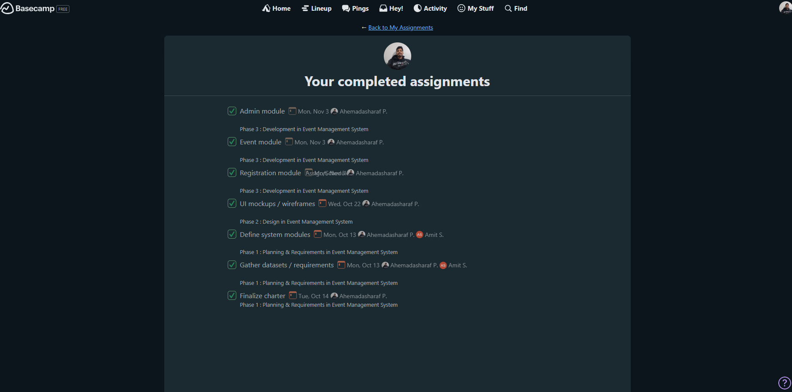
3.1 work done

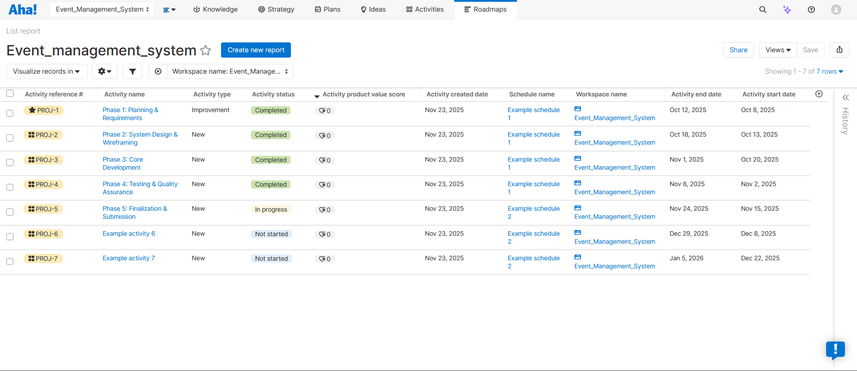
3.2 Roadmap
BASECAMP PROJECT PLAN
4.1 To-Do Lists
Five separate lists were created:
- Planning & Requirements
- Design & Wireframing
- Development
- Testing & Fixes
- Final Submission
Each list contains tasks assigned to Ahemad or Amit.
4.2 Schedule Milestones
- Charter Finalized
- Design Approved
- Development Complete
- Testing Finished
- Final Submission
4.3 Critical Path
The following tasks were marked as Critical Path:
- Charter completion
- Design approval
- Core development
- Testing
- Final presentation & report
- GitHub final version
4.4 Ontario Statutory Holiday Adjustment
Milestones were scheduled to avoid Ontario holidays such as Family Day, Labour Day, and Thanksgiving.

GITHUB REPOSITORY
Section 5: GitHub Repository
The GitHub repository includes:
- Complete project folder
- README.md file with instructions
- Three required commits:
  - Initial setup
  - Progress update
  - Final version
- A public link added to Basecamp Docs & Files
Repository Link: https://github.com/ahemad18/Group_6_event-management-system.git

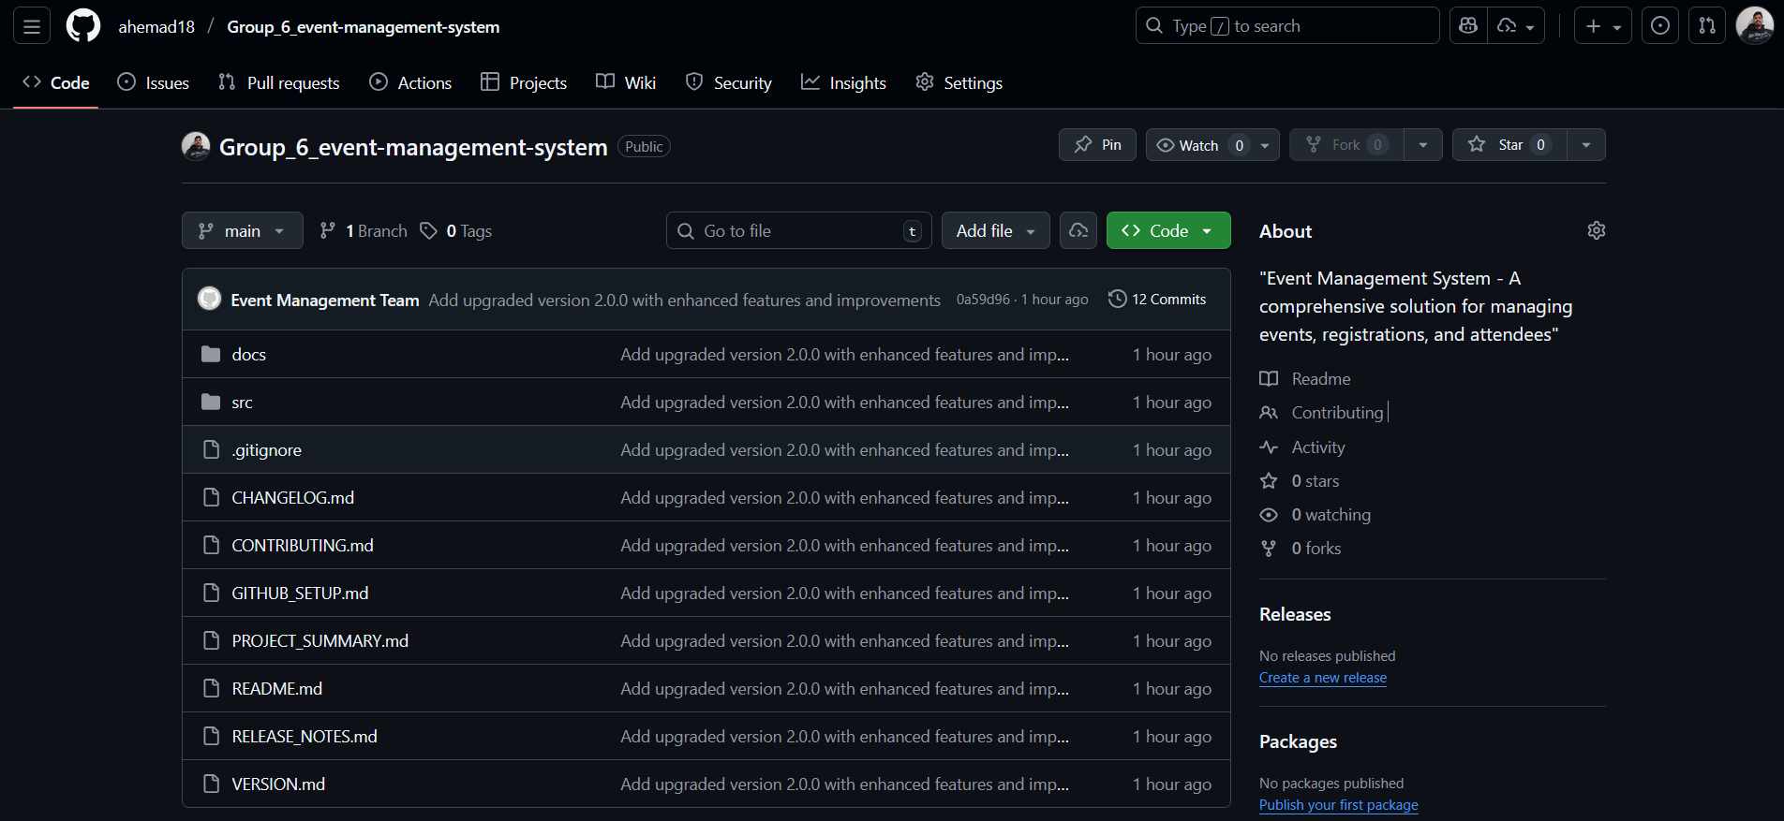

LLM USAGE STATEMENT
Section 6: LLM Usage Statement
Large Language Models (LLMs), notably ChatGPT, were utilized to help with project documentation, produce organized templates, and improve the clarity of written material. The team vetted and reviewed every generated material, making necessary modifications to guarantee correctness and coherence. The project team was responsible for all critical thinking, decision making, and final approval. The group bears full responsibility for the final submitted work.
The project team takes full responsibility for the accuracy, originality, and quality of the submitted work. All recommendations received from the LLM were critically evaluated and rewritten in the team’s own words to reflect original thinking and understanding.
PROMPTS USED
Section 7: Prompts Used
Throughout the process, ChatGPT was engaged for advice, clarity, and guidance, not to replicate final material. Examples of advisory prompts used are as follows:
- Can you explain how to structure a project charter?
- What should be included in a product roadmap?
- How do I organize Basecamp tasks and milestones?
- What is the best way to outline a final report for a project?
- How can I make sure my presentation covers all required sections?
- What should an LLM usage statement look like?
- How should I phrase changes made to a project charter?
- What are the key components of a critical path in project management?
These prompts were solely used to assist guide thinking, increase comprehension, and organize the project; the project team made all final decisions, language, and content creation.

APA 7 REFERENCES
Project Management & Software Development
PMI. (2021). A guide to the project management body of knowledge (PMBOK® guide) (7th ed.). Project Management Institute.
Sommerville, I. (2016). Software engineering (10th ed.). Pearson.
Pressman, R. S., & Maxim, B. R. (2020). Software engineering: A practitioner’s approach (9th ed.). McGraw-Hill.

Event Management & Information Systems
Allen, J. (2022). Event planning: The ultimate guide to successful meetings and events. Wiley.
Laudon, K. C., & Laudon, J. P. (2021). Management information systems: Managing the digital firm (16th ed.). Pearson.

Agile, Roadmaps, & Documentation
Layton, M., & Ostermiller, S. (2017). Agile project management for dummies (2nd ed.). Wiley.
Cagan, M. (2017). Inspired: How to create tech products customers love. Wiley.

GitHub & Basecamp References
Basecamp. (2024). Basecamp 4: Official product documentation. https://basecamp.com/help

In-text citations :

- (American Psychological Association, 2020) – Used for LLM usage ethics and APA guidelines.
- (Basecamp, 2024) – Used in sections explaining Basecamp project planning and collaboration.
- (Cagan, 2017) – Used for roadmap planning and digital product development principles.
- (GitHub, 2024) – Used in the GitHub repository section describing version control practices.
- (Government of Ontario, 2024) – Used in scheduling and statutory holiday alignment discussions.
- (Laudon & Laudon, 2021) – Used for information syst em justification in the project overview.
- (Layton & Ostermiller, 2017) – Used for agile planning, milestones, and iterative development references.

